Halloween
At
My School
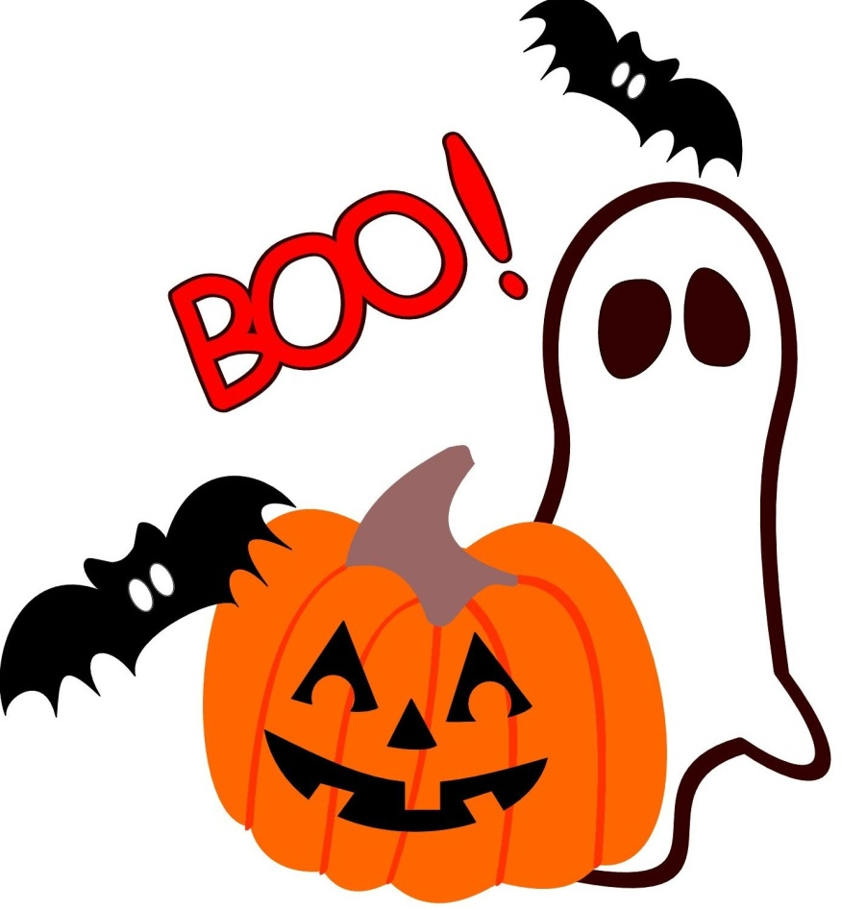

Halloween is on
October 31st each year.
It is so much fun!
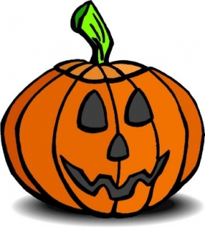

Sometimes, the teacher will say that little kids can wear a costume to school to
celebrate Halloween.
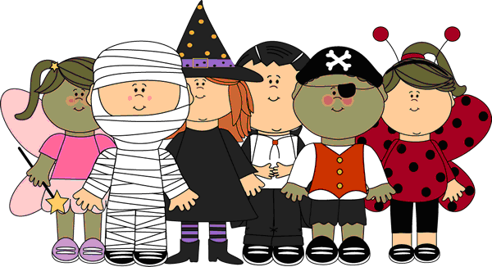

My class might walk around
the school for
trick-or-treating.
If I get a piece of candy, it would be nice to say,
“Thank you.”
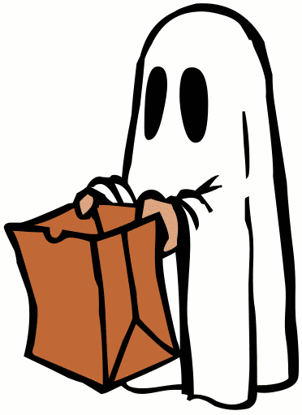

We will have spooky snacks
and drinks in my classroom. If I do not like the snacks or drink, I can just say, “No, thank you.”
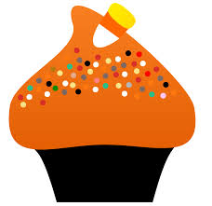

We might play games or
sing fun songs at the party. Someone might say, “Boo!”, but
they are just being silly.

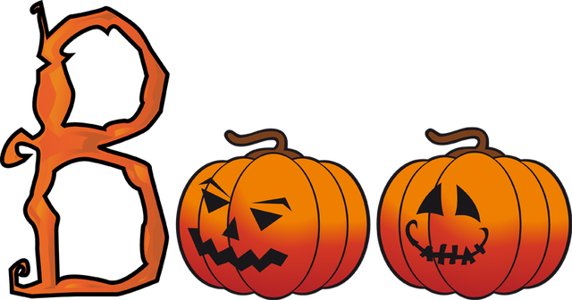

Some songs and games might be about ghosts and goblins.
They are not real,
it is just for fun.
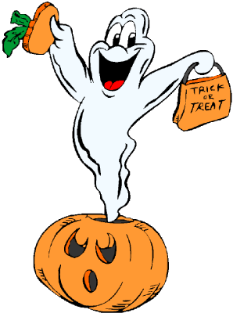
We might walk around the school for trick-or-treating.
If I get a piece of candy,
it would be nice to say,
“Thank you.”
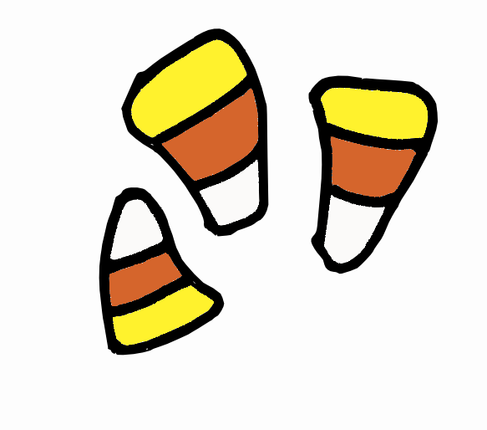

Halloween
Is a lot of fun!

